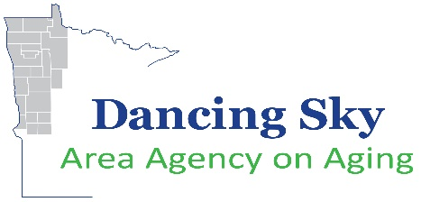
2022 Competitive Grant Notification

Funding Timeline

Vaccine Access (VAC5)
This competitive application is ONLY for Covid-19 Vaccination Access initiatives

For the 21 Counties of: Becker, Beltrami, Clay, Clearwater, Douglas, Grant, Hubbard, Kittson, Lake of the Woods, Mahnomen, Marshall, Norman, Otter Tail, Pennington, Polk, Pope, Red Lake, Roseau, Stevens, Traverse, and Wilkin.

Date | Activity
September 8, 2021 | VAC5 Funding Availability  Funding may be used as follows:  - Efforts related to COVID-19 vaccination outreach, including education, communication, transportation, and other activities to facilitate vaccination of older individuals; and  - Prevention and mitigation activities related to COVID-19 focused on addressing extended social isolation among older individuals, including activities for investments in technological equipment and solutions or other strategies aimed at alleviating negative health effects of social isolation due to long-term stay-at-home recommendations for older individuals for the duration of the COVID-19 public health emergency.  Applications available on-line at www.dancingskyaaa.org
September 15, 2021 | Proposals accepted for initial review. Proposals will be accepted and approved on a weekly basis until all funding is committed.
September 20, 2021 | Grant Review Committee meets and reviews applications. Awarding documents will be sent to accepted proposals for signature.
September 22, 2021 | Proposals accepted for initial review. Proposals will be accepted and approved on a weekly basis until all funding is committed.
September 27, 2021 | Grant Review Committee meets and reviews applications. Awarding documents will be sent to accepted proposals for signature.
November 30th, 2021 | Last day to submit a proposal.
December 4, 2021 | Northwest Regional Development Commission reviews final recommendations from Dancing Sky Grant Review Committee
December 31, 2021 | All VAC5 funding will be obligated by this time. Projects are strongly encouraged to have  activities completed by 12/31/2021 but MUST have activities completed by 9/30/2022.

